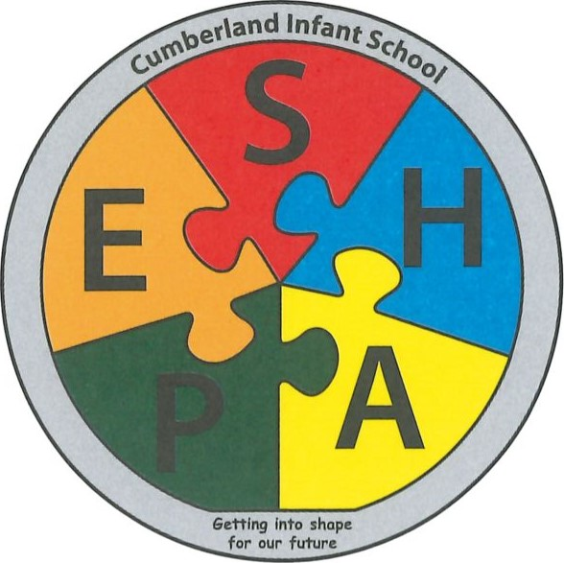
CUMBERLAND INFANT SCHOOL
Methuen Road, Southsea, Hampshire. P04 9HJ
Telephone: 023 9273 3161 • Fax: 023 9282 7184
Email: admin@cumberland.portsmouth.sch.uk
Web: www.cumberland.portsmouth.sch.uk

Headteacher: Mrs Rebecca Herbert BEd

Thursday 22nd October 2020

Dear Parent/Carers
News from the Head
I would like to thank everybody in the Cumberland Community (children, staff and parents) for working in partnership to make the first half of the Autumn term such a positive experience during a worldwide pandemic! As I write this, the children in school are totally over excited and extremely tired with a virtual disco and half term holidays looming. I know everybody is ready for a restful half term and time to reenergise for the next half of the autumn term.
The children are amazing us daily with the progress they are making. This afternoon, I can hear Year R busy with clever hands developing their fine motor skills through cutting, writing and sticking. I know the Year R team have been so impressed with the child’s recall of the letter sounds they have been taught this term. This week Year 1 wrote some amazing books all about Goldilocks and the Three Bears, with finger spaces, capital letters and full stops and with so much confidence and enjoyment. Yesterday was a joy to watch Year 2 arrive as the animals they had been studying in their Zany Zookeeper Topic plus they have achieved so much in adding and subtracting in Maths, really catching up!
Learning packs
Today your child will bring home a Learning Pack which we hope you will support your child to do over the next half term. It is gradual learning which you can keep going back to with your child up to Christmas. Remember to log on to Bugs Club and Education City over half term with your children. I know some children are beginning to get certificates for reading ten books or more and I have heard that many children are really enjoying reinforcing their learning through Education City.
Parents virtual meets and telephone calls
This week parents have been having telephone conversation or virtual meeting, if they worked with their child’s teacher. It has been lovely to hear the feedback that the children have settled so quickly into life back at Cumberland Infants and how much learning they are sharing at home. If you have not had a call yet, the teachers will be speaking to you after half term at some point, after school. Thank you for your patience as virtual meetings are new learning experience for us all. After half term we would like to send your children’s topic books home to see but please can we have them back into school a week later.

2

Hot Dinners
As you are all aware, we will be serving hot dinners from after half term. If you haven’t already done so please could you select your child’s menu choice and return to school as soon as possible. The children will still be eating in their bubbles mainly in their classrooms. The hot food will be provided on a little tray, like airplane food is served!
Website
We are currently trying to develop our website. All letters you receive through Parent Mail will be added to the website. Currently, we are developing a website team, so photos of your child will be added under the year group tab. Already there are photos of YR and the farm animals, Year 1 Goldilocks rap and Year 2 at Marwell Zoo and their animal parade.
Lost item
Please can you look in your child’s pockets, book bag, P.E kit and lunch box for a small dark grey/black smooth and shiny pebble like electronic device from a child’s hearing aid which has been lost this week. If you find it please email head@cumberland.portsmouth.sch.uk

COVID-19 during half term
During half term if your child or anybody in your family tests positive for coronavirus please could you email head@cumberland.portsmouth.sch.uk immediately so I can take the necessary action. If you choose as a family to travel abroad, in a country currently on the Government Restricted list, please ensure you quarantine for 14 days from the day of your return.
I wish you all a safe and happy half term.
Yours sincerely,
Becky Herbert
Headteacher

